 PROJECT REPORT TEMPLATE

1. INTORDUCTION
   1. Overview

As of my last knowledge update in September 2021, I do not have specific information about a travel company named "Travel Trax Tours." Travel companies can vary widely in their offerings, so it's best to get information directly from the source for the most accurate and up-to-date details.

1.2 Purpose

**Financial Management**: Zoho Books helps businesses manage their financial data effectively. It provides tools for bookkeeping, invoicing,expense tracking, and bank reconciliation.

**Invoicing and Billing**: Users can create and send professional invoices to clients and customers. It streamlines the invoicing process, which is essential for cash flow management.

**Expense Tracking**: Zoho Books allows users to record and categorize expenses, making it easier to monitor and control costs.

**Financial Reporting**: The software generates various financial reports, such as profit and loss statements, balance sheets, and cash flow statements. This helps business owners and accountants gain insights into their financial health.

1. Problem Definition & Design Thinking
   1. Empathy Map

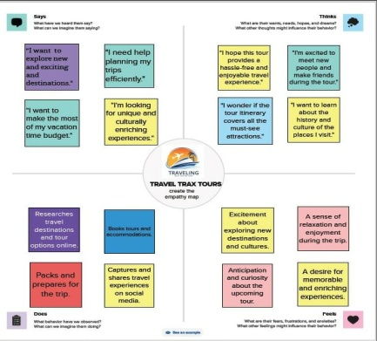

* 1. Ideation & brainstorming Map

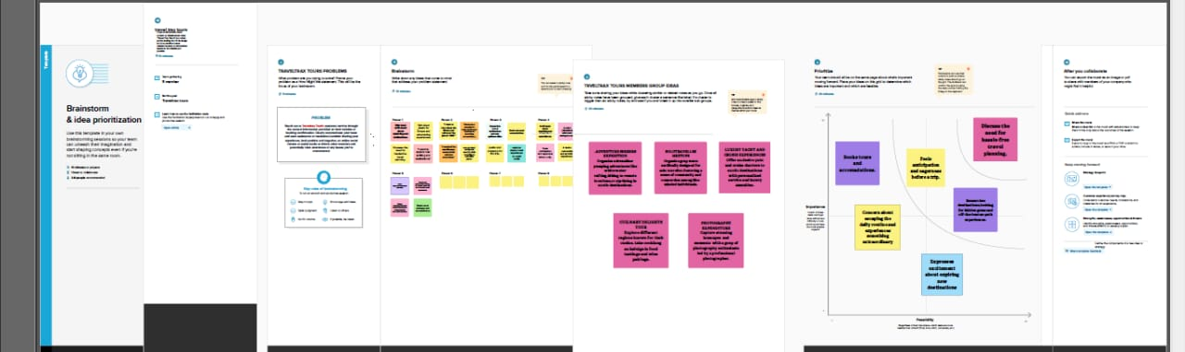

1. RESULT

PROFIT AND LOSS ACCOUNT

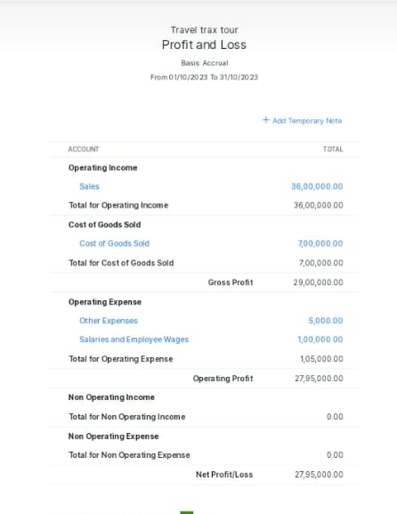

BALANCE SHEET

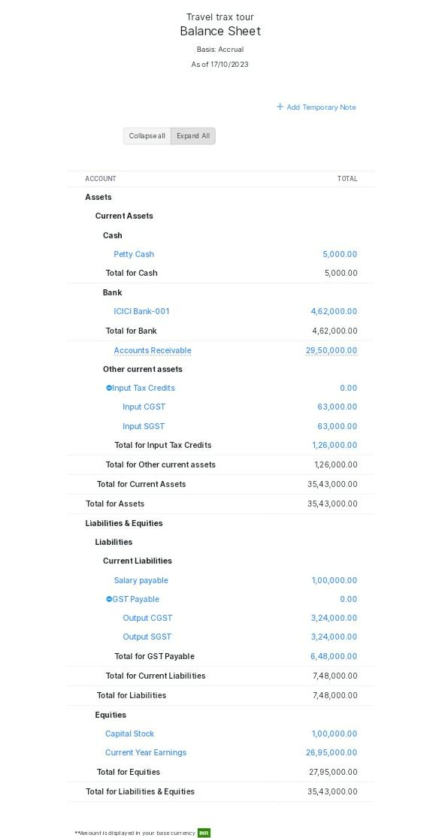

4.ADVANTAGES AND DISADVATAGES

1. **User-Friendly Interface**: Zoho Books is known for its user-friendly interface, making it easy for individuals with varying levels of accounting expertise to navigate the software.
2. **Affordable Pricing**: It offers competitive pricing plans, particularly suitable for small and medium-sized businesses. This can be a significant cost-saving compared to some other accounting software.
3. **Cloud-Based**: Zoho Books is cloud-based, allowing users to access their financial data from anywhere with an internet connection. This ensures data availability and security.
4. **Invoicing and Payment Integration**: It offers invoicing features and integrates with popular payment gateways, making it easy for businesses to create and accept online payments.
5. **Financial Reporting**: Zoho Books generates various financial reports, enabling businesses to gain insights into their financial health and make informed decisions.

**Disadvantages**:

1. **Limited Advanced Features**: While Zoho Books is suitable for small and medium-sized businesses, it may lack some advanced features that larger enterprises may require. Businesses with complex accounting needs may need to consider other software options.
2. **Limited Scalability**: While it's great for small and medium-sized businesses, it may not scale well for very large companies with high transaction volumes.
3. **Customer Support**: Some users have reported mixed experiences with Zoho's customer support. Response times and the level of assistance may vary.
4. **Local Tax Compliance**: Zoho Books' effectiveness in handling local tax regulations may vary depending on the region. Users may need to consult local experts for complex tax situations.

5.APPLICATIONS

1. <http://www.mural.co/>

2. <http://www.github.com/>

3. <http://nm.smartinternz.com/>

4. <https://www.google.com/url?q=https://portal.naanmudhalvan>

5. <http://books.zoho.com/>

6.CONCLUSION

In conclusion, Zoho Books is a valuable accounting tool for many small and medium-sized businesses, offering ease of use, affordability, and essential accounting features. And it may not be the best choice for larger enterprises with more complex financial operations. It's important to assess your unique needs and consider both the advantages and limitations of Zoho Books when making a decision.

7.FUTURE SCOPE

1. **Mobile Accessibility**: Accounting software will be increasingly accessible via mobile devices, allowing users to manage their finances on the go.
2. **Sustainability and ESG Reporting**: Companies may emphasize sustainability features, enabling businesses to track and report on their environmental, social, and governance (ESG) initiatives.
3. **Enhanced Reporting and Analytics**: Expect improved reporting and analytics capabilities, providing users with deeper insights into their financial data.
4. **User Education and Support**: To accommodate users with varying levels of accounting expertise, accounting software providers may enhance user education and support resources.
5. **Data Security and Compliance**: Accounting software will continue to focus on data security and compliance, addressing the concerns of businesses and individuals regarding data privacy and legal regulations.
6. **Customer-Centric Development**: Software providers like Zoho may continue to prioritize customer feedback and suggestions in their product development process.

To stay up to date with the specific future scope of Zoho Books, I recommend visiting Zoho's official website and keeping an eye on their product updates, blog posts, and announcements. They are likely to evolve their product in response to the changing needs of businesses and advancements in technology.

8.APPENDIX